**LabelCast Label Printing Software**

**User Manual**

Version 1.1Dec 2024

**Overview**

LabelCast is software which allows printing of barcode labels to Zebra label printers, based on data manually input or supplied by a database. Typically, you would input one or more data fields, which are used to look up additional information in a database and then combined to print a barcode label.

At this time, only label printers from the company Zebra are supported.

The software comes in two flavors:

* Windows desktop application
* Web application

If you have a single workstation with a dedicated Zebra label printer, or just a few workstations, each of which has their own label printer where each workstation has individual label needs, the simplest solution is to install the desktop application on each workstation.

If multiple users need to print the same type of label, or if they share printers, or if diverse types of devices exist which need to print labels, the web application is a better fit.

**Why This Application?**

A lot of labeling software exists. However, most of them are intended for general purpose labelling and are using Windows printer drivers. This is fine, but Zebra printers are special case – using the Windows printer driver to print barcode labels often results in barcodes which cannot be properly read in all barcode readers.

To properly print barcodes on Zebra printers, the native Zebra printer language ZPL must be employed to send the label. This app is intended to do just that.

**Label Design and Workflow**

LabelCast does not support designing label templates. This must be done by a separate program, such as the free *Zebra Designer* from the Zebra website.

The work flow is as follows:

1. Install Zebra Designer for Developers
2. Create a label design
3. Save the label design as a print template file – a text file containing Zebra ZPL commands.
4. Install LabelCast desktop or web application.
5. Configure LabelCast to use your label design, specifying database details and fields to be input by the user.
6. Print the labels using either the desktop app or web application.

**HTTP API for JSON and XML**

You can also configure LabelCast to print labels using a HTTP API. You can submit label data in XML or JSON format. Optionally, the label data format can be validated through a XML / JSON schema.

This is only supported when the web application has been installed.

**Designing Label Templates**

LabelCast does not support designing label templates. Any label designer program can be used – however, it must be capable to save label formats in the native Zebra format, i.e. a text file containing ZPL-II commands.

We recommend the program **Zebra Designer 3 for Developers** which you can download free of charge from the [www.zebra.com](http://www.zebra.com) website. Select the following from the menu:

Support and Downloads > Software Support > Printer Application Software > Zebra Designer 3 for Developers

You can also use the regular (non-developer) edition. It is easier to use the developer version, though, because it is specifically designed for creating and saving label template files and it does not require you to install an actual Zebra printer.

You begin by creating a new label, define size and label properties. You can then add fixed and variable text and barcodes as you require. Many tutorials exist on the internet, Zebra website etc.

To save the label as template file, select

File > Store

from the menu.

In the options shown, first select ZPL as “Recall stream format”, then under “Operation”, choose “Generate print files with variables”. Choose a file name and browse to a location on disk.

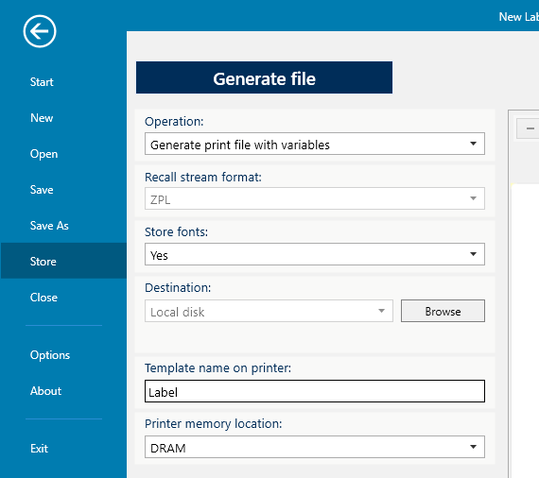

You have now a text template file containing any variable names you defined in the label design process, which you can with the LabelCast software.

**Desktop Application**

**Installation**

System Requirements: Windows 10+, Windows Server 2016+

Extract the LabelCast Desktop ZIP file to a temporary directory, then execute LabelCastDesktop.exe.

This will install the LabelCast application, and the prerequisite Windows Desktop Runtime. If this runtime is already installed on your device, you can skip that step.

**Using the Desktop App**

The desktop application opens to the data entry / label printing page. Users input data to get labels printed. Which input field names show here depends on the configuration of the selected profile.

Select the label profile and printer from the drop down boxes.

When first installed, it has a demo label configured, taking data from a local SQLite database. All configuration files are located at “C:\Program Info\LabelCast\”.

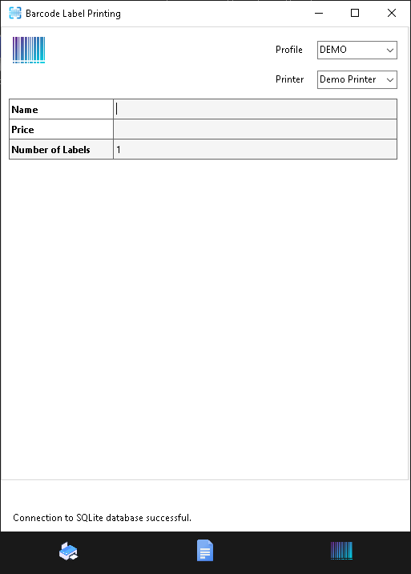

Menu buttons

To facilitate input of data, use the ENTER key after each value. This automatically moves the cursor to the next input field. On the last input field at the bottom, pressing ENTER also automatically starts printing the label.

You can configure two things using the menu buttons:

* Label Profiles
* Label Printers

A **label profile** is a collection of settings which configure which data should be input, whether a database should be queried for further information, database connection and query information, the label template and the default printer to use. A profile represents a specific type of label and all information regarding it.

**Label printers** can be configured separately. Each profile has a default printer which will be used in absence of further specification. But any user can override this, allowing the same type of label to be printed to many printers.

Note

The desktop application is used for profile configuration for the web application as well – the web app itself has no configuration pages. The desktop application must therefore be installed in addition to the web application. In this scenario, you can use the desktop app as a convenient test system, allowing for quick tests of your label profile definitions and label formats.

**Basic Label Profile Configuration**

To create a new profile, click on the ADD button of the app. After entering the desired property values, press SAVE to persist the profile definition.

Following are the properties which can be configured for a profile.

General

Name Name of the profile (must be unique)

Description Detailed description

Abbreviation Abbreviated name – this will show in the selection dropdown

Database

Database Type Currently supported are SQLite, PostgreSQL, MS SQL Server, Oracle

Connection String Input here the connection string to connect to your database

Time Zone Time zone of the database server. Some databases require this information which is why this property exists.

SQL Query A query string to obtain a single record based on user input. The WHERE clause of the query should contain the configured Search-Fields and the SELECT clause should contain the Data-Fields (see below Fields section). Field names are referenced in curly braces: ID = {id}

Search SQL Query This is a separate query to obtain one or more records to choose from, when the user entered percent (%) wildcard characters in his input. The query must include all of the Data-Fields in the SELECT clause – the same as in the main SQL Query.

Display Field Name of field to display to the user when showing the list of choices from the Search SQL query.

Fields

Search Fields List of fields a user should input to filter the database query by (these would appear in the WHERE clause of the SQL query). They are shown in the UI as input fields.

Data Fields Field names of the database query result (SELECT clause column names)

Editable Fields Fields for user input which are not sent to the database for query and are not database result fields either. These fields appear in the UI as input fields.

Search Fields and Editable Fields are optional. You do not need query a database at all, and you do not need to have additional editable fields.

The same field can appear in both Data Fields and Editable Fields. Manual edits override the values from the database, allowing the user to edit the value returned from the database.

Label Printing

Label Template Path to Zebra ZPL label template file

Default Printer This is the default printer to use for labels of this type.

There are further configuration properties related to JSON and XML APIs, which are described later in this manual.

**Example**

Name Standard Label

Description Standard Label for code, description and price

Abbreviation STANDARD

Database Type SQL Server

Connection String Server=mySRV; Database=myDB; Trusted_Connection=True;

Time Zone UTC

SQL Query SELECT DESCRIPTION, PRICE FROM TEST WHERE ID = {Code}

Search SQL Query SELECT DESCRIPTION, PRICE FROM TEST WHERE ID LIKE {Code}

Display Field Description

Search Fields Code

Data Fields Description, Price

Editable Fields Price, Weight

Label Template c:\Templates\standard_lbl.prn

Default Printer OFFICE2

In this example, the field “Price” appears both in Data-Fields and Editable-Fields – the database query will return the value, but the user can then still change it. Manual edits override the values from the database.

**Label Printer Configuration**

Name The name of printer (does not need to be the network host name). Names should be short as they appear in the selection dropdown.

Description Detailed description.

IP Address Network address to reach the printer

Port Network port number. By default, this is 9100 for Zebra printers.

**Example**

Name OFFICE2

Description Zebra barcode label printer No. 2 in the office

IP Address 192.168.0.151

Port 9100

**Advanced Profile Configuration - JSON and XML API**

If the web application is installed, it supports submitting label data in JSON or XML format over HTTP as POST request.

Profile and printer configuration is always done through the desktop app, however. Additional configuration properties exist to enable API submissions. These are explained in detail in the section Label Request API of this manual.

**Web Application**

**Installation**

System Requirements: Windows 10+, Windows Server 2016+ (or any common Linux distro)

LabelCast is an ASP.Net Core 8.0 web application, and can be installed using the standard steps for deploying such web applications to a web server. ASP.Net.Core applications can be installed on Windows servers or Linux.

Example steps for a typical Windows Server installation

Install IIS (Internet Information Services)

Install ASP.Net hosting bundle 8.0 (Microsoft .Net 8.0 Windows Server Hosting)

Create a folder for the web app

Create a site in IIS, specifying the DNS name of the web server, and link the app to the above folder

In the IIS application pool, select Basic Settings and set the following:

* .Net CLR version: No Managed Code

* Managed Pipeline Mode: Classic

Download LabelCastWebApp.7z and unzip it into the web app folder

Ensure that your DNS can find the application name you configured in IIS for the LabelCast application.

This will install the app in HTTP mode. If you need HTTPS, you need to add a certificate.

**Using the Web App**

Point your browser to the following URL

http://<your-server-dns-name>/labels/main

The main page opens, which resembles closely the look of the desktop app. There are no options to modify configuration settings for profiles or printers though. (Use the desktop app to change settings.)

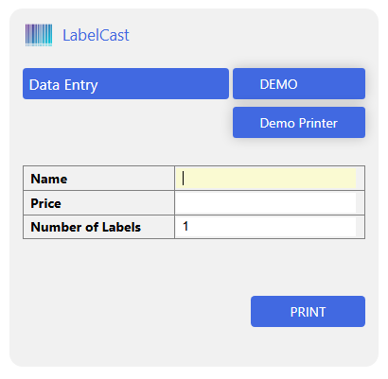

You can select which label profile and printer to use, and enter data to print labels.

In the above demo, the **Name** field is used to query the database which will retrieve the **Price** data, and an additional **Description** column. The Description column is not shown on the entry screen because the user cannot edit its value but it will print on the label.

**Support for Internet Explorer**

To open the web application from Internet Explorer 8 or later, point your browser to this URL

http://<your-server-dns-name>/labels/main/ie8

For Internet Explorer 6, use this

http://<your-server-dns-name>/labels/main/ie6

These URLs are intended to provide support for legacy environments where no other browsers are available. Their use is not recommended, and not all features are supported. Use alternative browsers – LabelCast runs just fine with the standard URL on the old Firefox version 52, which should be readily supported on most older operating systems.

**Label Request API**

If the web application is installed, it supports submitting label data in JSON or XML format over HTTP as POST request.

**Workflow of API Label Requests**

The label request data is parsed to determine which label profile should be used to print the label, and which printer. Certain properties and values must appear in the label request to match – this is configured in the Profile Map property – see below.

The app may optionally validate the label format against a JSON or XML schema if defined.

Then, values for the search-fields and editable-field variables are extracted, and the label sent to the printer.

To make this work, additional configuration properties are required.

There are two supported scenarios:

* Full label data is submitted (no database query)
* Partial info submitted, requiring database query

If a system such as an ERP is creating the label data, it would normally submit all of the data for a label which can then just be extracted and submitted to the printer.

In some cases, one may want to print labels from a list of codes or IDs and require a database query for each label to obtain the necessary full information for the label.

**URL for API Calls**

URL for a full label data request submission (no database query):

POST <server-name>/labels/printqueue

URL for a label request submission requiring a database query:

POST <server-name>/labels/dataqueue

**Advanced Profile Configuration - JSON and XML API**

Profile and printer configuration is always done through the desktop app, also if the web application is installed, since the web app contains no configuration pages.

Additional configuration properties exist to enable API submissions.

Configuration of the API is done directly in a profile – thus, you cannot have more than one type of XML request and one type of JSON request. If you do need support multiple types of label requests for the same label type, define multiple profiles using the same label template.

For JSON requests, the configuration specifies a mapping between the field names defined in the label profile and the corresponding JSON properties in the request. For XML, you specify an XPath expression to retrieve values from the XML request.

JSON Label Request Configuration

JSON Schema Path to JSON schema file. The file should follow the syntax defined at <https://json-schema.org/>. This file is only used when “JSON Schema Option” is set to “UseProfileSchema”.

JSON Schema Option You can choose to skip validation (DoNotValidate), to use a fixed file defined in the above ”JSON Schema“ property (UseProfileSchema), or to use the schema specified in the label request $schema property (in this case this is a relative URL – the file must be in the configuration directory)

JSON Profile Map List of JSON properties and respective values which must appear in the label request for this profile to be selected

JSON Search Field Map List of field names (identical to Search Field list) and corresponding JSON properties. LabelCast will use the values of those JSON properties to assign to the Search Field variables. If such fields are detected in the label request, this triggers a database query.

JSON Data Field Map List of field names (identical to Data Field list) and corresponding JSON properties. Data Field Map only needs to be configured for label data request which contain full label data, including fields which “normally” would come from a database query result.

JSON Edit Field Map List of field names (identical to Editable Field list) and corresponding JSON properties.

XML Label Request Configuration

XML Schema Path to XML DTD file. XSD is not currently supported – it must be a Document Type Definition (DTD). This file is only used when “XML Schema Option” is set to “UseProfileSchema”.

XML Schema Option You can choose to skip validation (DoNotValidate), to use a fixed file defined in the above XML Schema property (UseProfileSchema), or to use the schema specified in the label request $schema property (in this case this is a relative URL – the file must be in the configuration directory)

XML Profile Map List of XPath expressions and respective values which must appear in the label request for this profile to be selected

XML Search Field Map List of field names (identical to Search Field list) and corresponding XPath expressions to locate the values in the XML. LabelCast will use these values to assign to the Search Field variables. If such fields are detected in the label request, this triggers a database query.

XML Data Field Map List of field names (identical to Data Field list) and corresponding XPath expressions to locate the values in the XML. Data Field Map only needs to be configured for label data request which contain full label data, including fields which “normally” would come from a database query result.

XML Edit Field Map List of field names (identical to Editable Field list) and corresponding XPath expressions, as above.